**Middle East Technical University**

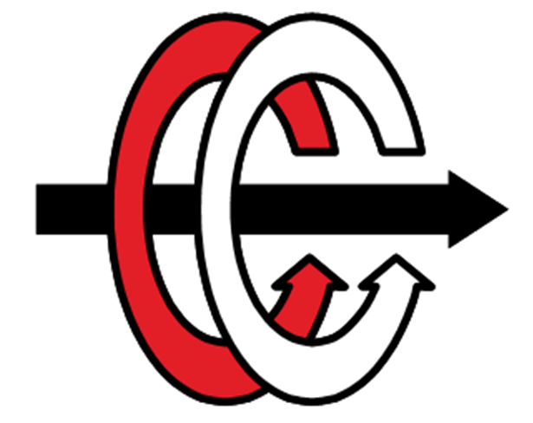

**EE493 Logbook**

**Student:** Mert Eren Kandilli

**ID:** 2304855

**Studio Coordinator:** Assist. Prof. Ahmet Cemal Durgun

**Company:** Indigo Tech

# October 27 – November 3 (10.27.2021-11.03.2021)

After determination of groups, we held a meeting with our coordinator and some other groups. We met and discussed the EE493 course, its requirements and expected contributions. We decided our weekly meeting time that we can present our progress and have chance to ask general questions to our coordinator.

Every week there is a seminar session about design course that help us during our desinging process. Until now I have attended two seminars presented by Assist.Prof. Ahmet Cemal Durgun and Assoc. Prof. Emre Özkan which are very useful.

After meeting with our coordinator, we decided to gather as a group to make a plan to write weekly report and business statement report. In this meeting we divided the project research and definition part of business statement report. I designed a multiple logos that symbolizes our company and group and we decided one of them. Next week I will read and investigate the “**Orbiter**” project. My goal is to understand the project, its advantage and disadvantages. I am planning to do it by trying to understand the parts we might have difficulties while doing it.

# November 3 – November 10 (11.03.2021-11.10.2021)

## November 4 (11.04.2021)

Business Statement Report template is prepared, and Mission and Vision statements samples presented to the group members.

## November 5 (11.05.2021)

Orbiter Project is reviewed, and a report is prepared to present the group members. Details about the project is explained on the Business Statement Report.

## November 10 (11.10.2021)

A meeting is held with group members and Assist.Prof. Ahmet Cemal Durgun, and we have talked about the importance of project selection week and problem-solving methods.

# November 10, 2021 – November 17, 2021(11.10.2021-11.17.2021)